# **Socio-Formal Interactive Educational Platform (SIEP)**

**Himanshu Dhiman*1, Rittik Pradhan*1, Himanshu Yadav*1, Kapil Kaushik*1**

**Mrs. Krista Chaudhary *2**

\**1Student, Krishna Engineering College, Ghaziabad, India*

*\*2Assistant professor, Krishna Engineering College, Ghaziabad, India*

**ABSTRACT**

*The world has been making tremendous technological growth for the last few decades, but most educational institutions in India use the ancient paperwork methods to do most of the work.*

*Currently students have no access to Teachers outside the institutions. For even small things like checking the marks of the previous tests, the students have to physically reach out to teachers and for various other purposes like checking the attendance student have to physically reach out to various teachers for respective subject as we currently don’t have a centralized attendance system where overall attendance can be seen moreover online copies of notes are currently shared using apps like WhatsApp which ends up making a mess and it becomes extremely difficult to find those files or notes when needed the most and furthermore any other special activity/event organized in the institute remains confined to the mess of those WhatsApp group chat and no more than that which means the alerts for the activities are not properly received to the students and hence leading to the less participants in the activities and concluding to lowering the moral of activity organizers.*

***Keywords:*** *Organizational Vision, Latest Activity Updates, Subject-wise Channels,*

*Profile View, Social Interacting and doubt clearing Channel.*

---------------------------------------------------------------------------------------------------------------------------------------

Date of Submission: 02-06-2021 Date of acceptance: xx-xx-xxxx

---------------------------------------------------------------------------------------------------------------------------------------

1. **INTRODUCTION**

The world has been making exponential technological growth in recent times, but most educational institutions in India use the ancient paperwork methods to do most of the work.

Students have no access to Teachers outside the institutions. For even trivial things like checking the marks of the previous test, the students have to physically reach out to teachers.

The online copies of notes are currently shared using apps like WhatsApp which ends up making a mess and it becomes extremely difficult to find those files when needed the most.

**So, we propose a Social Media Type platform implemented in a formal manner providing ease of access to students and help them learn interactively by allowing them to reach out to teachers, seniors and juniors alike : SIEP**

SIEP provides different channels for different subjects where anyone in the channel can share notes of that particular subject. The channels could also be made Class or Section wise which will help the teacher maintain Attendance and Marks of the students.

There would be sub-channels where anyone could discuss their doubts with every teacher related to that subject.

To make this app into a social platform there would be a news feed on the home page of posts which could be made by anyone. Information and photos about various events going on in the institute could be posted there.

**METHODOLOGY**

Comparison of various Android based Messaging Applications are to be done in this paper on the basis of accuracy metric, Built-in security, and privacy features as large amounts of data are being transmitted over the internet when people make use of these kind of Apps. The project originated from a popular application called “Telegram”, This Application is a cross-platform cloud based Instant Messaging platform which was launched for ios in August 2013 but now It is available for Android, iOS, Windows Phone, Windows, macOS and GNU/Linux in addition to a web app. Telegram emphasize on sending messages and exchange videos, photos, stickers, audio, and files of any type accurately up to 2 GB each. As all these functionalities and services for the program have been explained, the main structure and construction of the project has been basically illustrated with its goals.

**Related Works**

Messaging Apps like Telegram and WhatsApp are well known and very popular multi platform Messaging services. The Headline feature of both of these is Privacy, and to ensure this it employs end-to-end encryption which stops those outside a two-way conversation be it a company, hackers, or someone unauthorized from seeing what data has been sent. 1. Telegram Telegram is a cross-platform multi platform Instant Messaging service founded by “Pavel Durov” a Russian entrepreneur for ios in August 2013. Telegram is not a just another Messaging app. Although, It’s core functionalities like messaging other Telegram users, create group chats, calls, and send files and stickers. is same as most other messaging apps. Telegram uses encryption in calls and it’s “Secret chat” which doesn’t means it is more secure and private than WhatsApp. Both services uses two factor authentication. According to the FAQ page of Telegram, It is said that the company is funded by the Founder and

CEO “Pavel Durov” and not through data sharing, collection and advertisements. In other words Telegram provides the Internet privacy as protecting your personal data from Third party access such as marketers, advertisers etc. Telegram offers excellent features like Self-destruct timers, Global message deletion, Large file size limit. Telegram is designed as a light app, reliable and fast. Telegram also provides bots which is an automatic answering account that can respond to specific text command by answering with preformatted text. 2. WhatsApp WhatsApp, is an American freeware, cross-platform messaging an d Voice over IP service owned by the giant Facebook. WhatsApp was founded by Brian Acton and Jan Koum in September 2007 for Android. WhatsApp is the most engaged top social messaging application. It is a well known fact that most of the smartphone users uses WhatsApp messenger. If there can be a competent for WhatsApp, in all probabilities then it will be the Telegram. But there are some freaks, geeks cult prefer Telegram than WhatsApp. Initially WhatsApp was criticized for lack of encryption and sending messages as plain text. Encryption in WhatsApp was first added in May 2012. In 2016, WhatsApp was widely praised for the addition of end-to-end encryption and earned a 6 out of 7 points on the Electronic Frontier Foundation's "Secure Messaging Scorecard". Just like Apple’s iMessage and Signal, WhatsApp has a number of advanced security features like end-to-end encryption. WhatsApp couldn’t read your messages as all the messages are secured so that only the sender and receiver can view them. WhatsApp is gaining more populariry than it’s competetors like facebook, messenger which is it’s own sibling and Telegram as telegram doesn’t supports Video Calling.

1. **RESULTS**

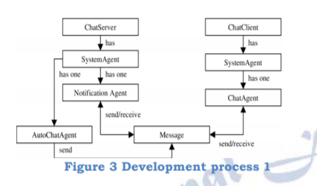

Figure 3 Development process 1 The Flow Chart describes the development process that include all the phases in the software development life cycle. This chart illustrates very well how the project is carried out and how the development was managed. After the program is completed, the program still needs future maintenance to form it available and stable to execute. The program are going to be tested after a particular period of time and debug each of the function and possible bugs, whenever a possible bug is detected; the program may need to be refined to fix the bugs for better design. Meanwhile, there will be updates, enhancements and more add on to the database to increase the database capacity. This project’s main focus is on privacy: messages shared between users should be encrypted to maintain privacy; Robustness: In case users device crashes, a backup of their chat history must be stored on remote database servers to enable recoverability and performance application must be light weighted.

1. **DISCUSSION**

As this project provides a platform to initiate a real-time chat. On the server side it ensures the reliable infra-management services for chat within the app. This application or messaging system aims to provide a platform for two individual users separated by a certain geographical distance to communicate with each other, through the Internet with the help of various Firebase tools. In firebase you don’t need to write the server side code. Data in the Firebase real-time database is always stored as key-value pairs. FirebaseUI uses a very class named FirebaseListAdapter, which dramatically reduces the effort required to display a ListView using data which present in the Firebase real-time database. It will be used to fetch and display all the Chat Message objects that are present in the database of firebase. The minimum requirements for this Android App are: • Android 4.0 (API level 14) or higher • Java 7 or higher • Gradle version 3.4.0 or higher It is very simple to implement the chat, firstly a user logs in and sees a list of channels then he can select or creates a channel, and sends a message to the channel while receiving messages from other users and communicators within the channel. In this project, Two types of channels are present: open and group. Open channel is a public channel and anyone can participate in and chat with others. And the group channel is a private channel that users can join as new members through invitation only, and has numerous distinctive properties and features compared to an open channel. There are a variety of group channel subtypes such as a public group channel working like an open channel as shown in fig.1.

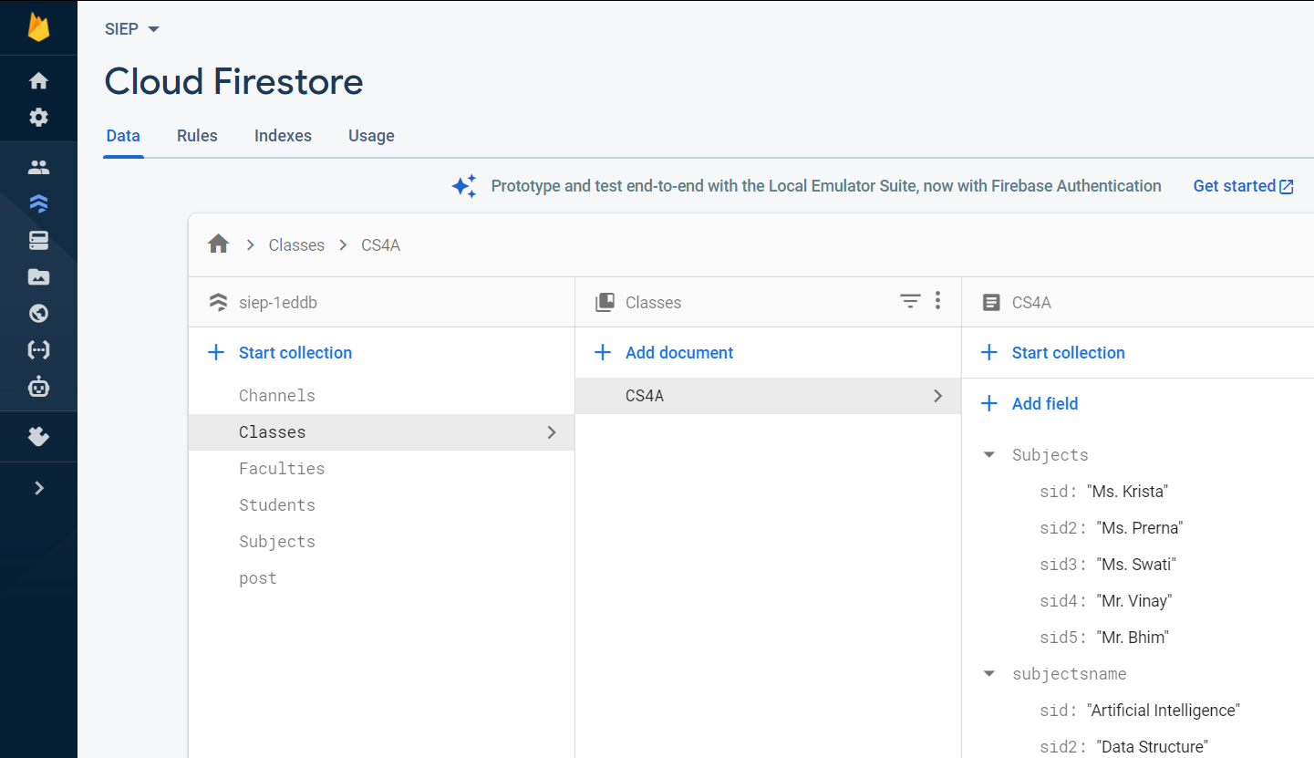 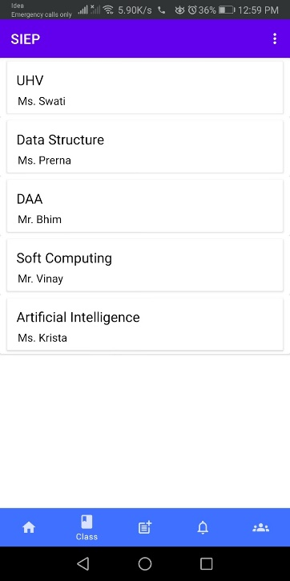

We have also intended the Delivery receipt feature(Double tick) which indicates whether a message has successfully been delivered to all the recipients. Delivery receipt works in a similar way as WhatsApp to read receipt. The server stores the timestamp of the message last delivered. The timestamp is then recorded per user and per channel. When a message is delivered to an online group channel, it is automatically marked as delivered and the other online members are notified of delivery receipt. The project is very useful and because of the flexible nature of the Firebase tools, the application is a step forward in the right direction in the context of Instant Messaging. On completion of this system, we are left with a fully functional Instant messaging application capable of sending messages in real-time and images were also being transferred. The Firebase services are important in the sense that those tools made the development of this applications a lot more efficient and lot faster compared to building a traditional server-side database using a scripting language. The application is user-friendly and intuitive, so using it is not a difficult task. No program has a perfect design without any flaws, it is same here in this project. Even though the program includes the primary functions implemented and working properly, there are still many things that can be done to improve its performance.

**REFERENCES**

[1] Bill Philips, Chris Stewart, Kristin Marsicano. Android Programming: The Big Nerd Ranch Guide. 3rd Edition. Arizona: Big Nerd Ranch; 2017. [2] Kumar, S., et al. Embedded end-to-end wireless security with ECDH key exchange. in Circuits and Systems, 2003 IEEE 46th Midwest Symposium on. 2003: IEEE. [3] Dashtinejad, P., Security System for Mobile Messaging Applications. 2015 [4] Cortjens, D., Spruyt, A. & Wieringa., W. F. C., n.d. "WhatsApp Database Encryption Project, s.l.: s.n. [5] Thakur, N., 2013. Forensic Analysis of WhatsApp on Android Smartphones.. Master’s thesis, University of New Orleans, , Volume 1706. [6] Barghuthi, N. A. & Said., H., 2013. Social Networks IM Forensics: Encryption Analysis.. Journal of Communications, 8(11)

1. **REFERENCES**
2. Traffic Sign Detection and Recognition using a CNN Ensemble Aashrith Vennelakanti, Smriti Shreya, Resmi Rajendran, Debasis Sarkar, Deepak Muddegowda, Phanish Hanagal Affiliation: Qualcomm India Private Limited, Bangalore
3. An Automatic Traffic Sign Detection and Recognition System Based on Colour Segmentation, Shape Matching, and SVM Safat B. Wali, Mahammad A. Hannan, Aini Hussain, and Salina A. Samad Department of Electrical, Electronic & Systems Engineering, Universiti Kebangsaan Malaysia, Jalan Reko, 43600 Bangi, Selangor, Malaysia.